##### VITAL SECURITY

***Services Lahore***

***Ref: Date:***

***TO WHOM IT MAY CONCERN***

This is to certify that Mr. **<Name>**

S/o **<fname>** has been working

with us from <From2> to <To2>

as **<Designation>**.



During his stay, we found him very honest, hardworking, and intelligent, having good knowledge in filed.

He worked at Bank Al-Falah Shah Alam Market Lahore Branch

We Success for his future life.



**MANAGER**

H

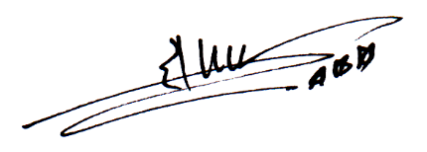

***10-B, Garden Town, Lahore. Tel: 042-7652470***